**Assignment 7**

1. Write a query that lists each order number followed by the name of the customer who made the order.

**Select o.onum,c.cname from orders o left join customers c on o.snum=c.snum;**

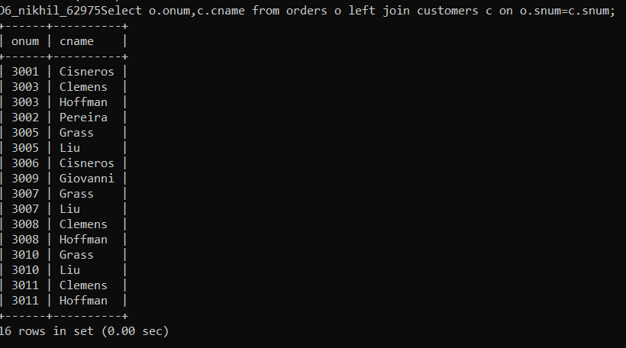

1. Write a query that gives the names of both the salesperson and the customer for each order along with the order number.

**Select s.sname,c.cname,o.onum from salespeople s inner join customers c on s.snum=c.snum inner join orders o on o.snum=c.snum;**

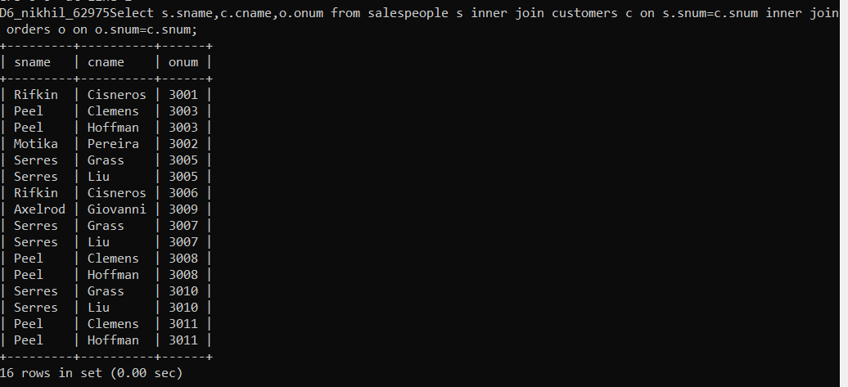

1. Write a query that produces all customers serviced by salespeople with a commission above 12%. Output the customer’s name, the salesperson’s name, and the salesperson’s rate of commission.

**select c.cname,s.sname,s.comm from customers c left join salespeople s on c.snum=s.snum where s.comm>=0.12;**

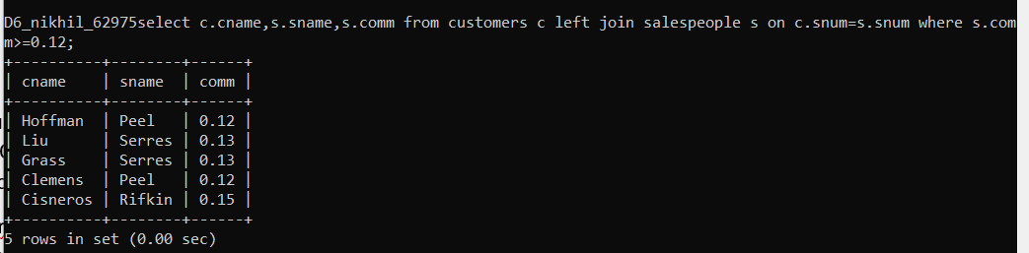

1. Write a query that calculates the amount of the salesperson’s commission on each order by a customer with a rating above 100.

**select s.sname,sum(s.comm),c.rating from customers c inner join salespeople s on s.snum=c.snum where c.rating>100 group by s.sname,c.rating;**

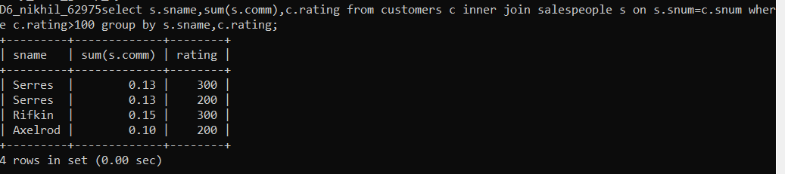

1. Write a query that produces all pairs of salespeople who are living in the same city.Exclude combinations of salespeople with themselves as well as duplicate rows with the order reversed

**select distinct s.sname,r.sname,s.city from salespeople s inner join salespeople r on s.sname<r.sname where s.city=r.city;**

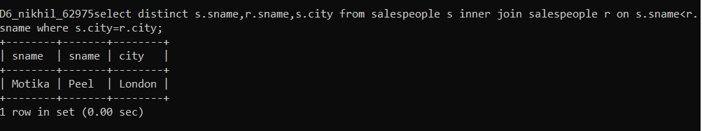

**Note : To solve below queries use “spj” database**

1. Display the Supplier name and the Quantity sold.

**select ss.sname,sps.qty from s ss inner join sp sps on ss.`s#`=sps.`s#`;**

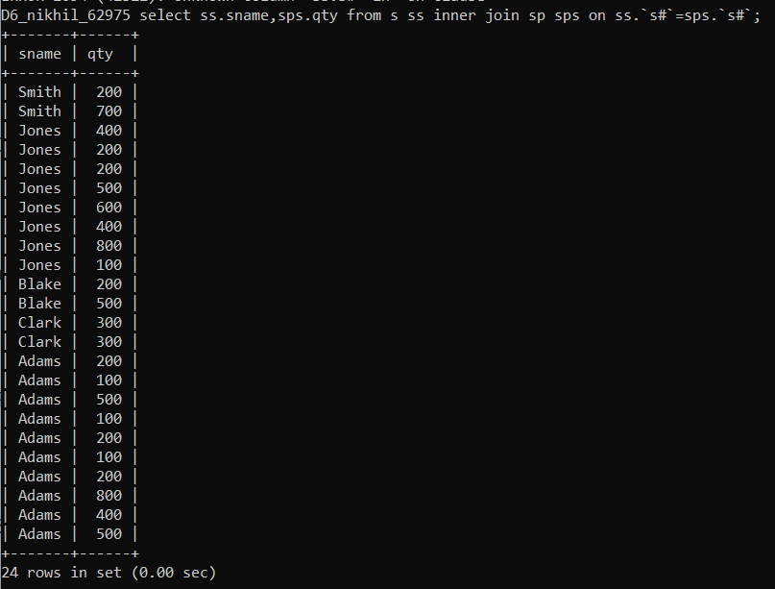

1. Display the Part name and Quantity sold.

**select pp.pname,sps.qty from p pp inner join sp sps on pp.`p#`=sps.`p#`;**

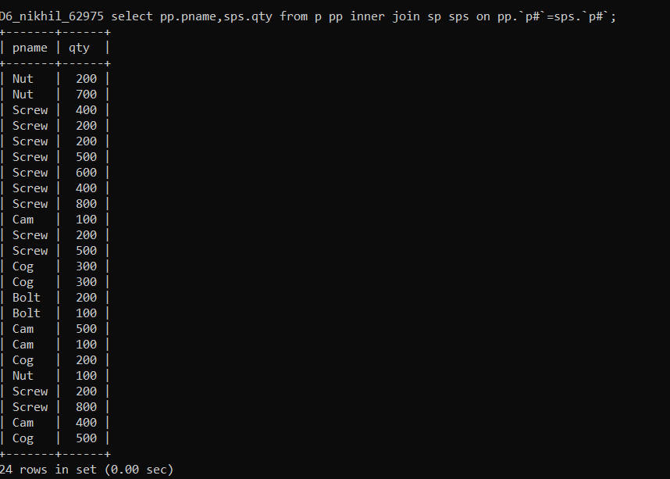

1. Display the Project name and Quantity sold.

**select jj.jname,sps.qty from j jj inner join sp sps on jj.`j#`=sps.`j#`;**

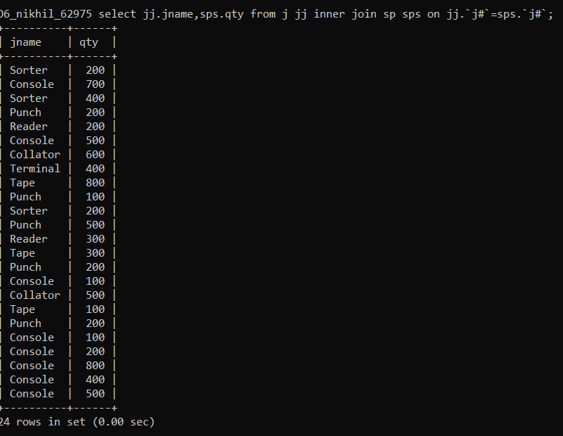

1. Display the Supplier name, Part name, Project name and Quantity sold.

**select ss.sname,pp.pname,jj.jname,sps.qty from s ss inner join p pp on ss.city=pp.city inner join j jj on ss.city=jj.city inner join sp sps on jj.`j#`=sps.`j#`;**

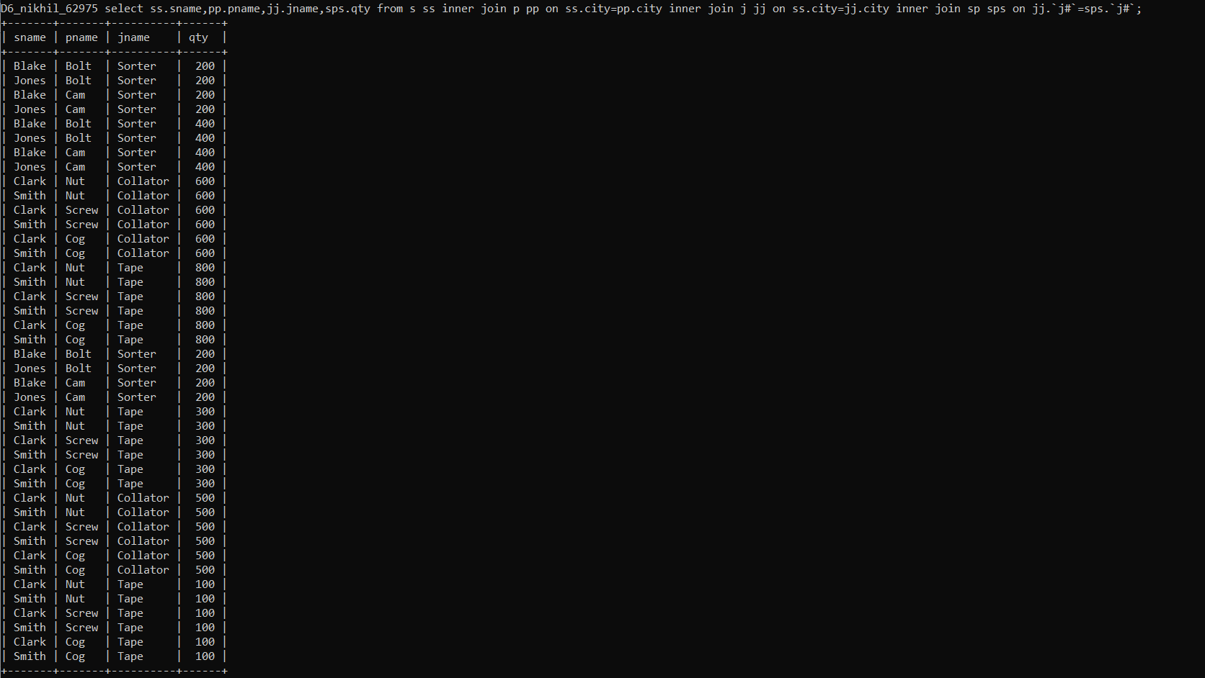

1. Display the Supplier name, Supplying Parts to a Project in the same City.

**select distinct ss.sname,pp.pname,jj.jname,ss.city from s ss left join p pp on ss.city=pp.city left join j jj on ss.city=jj.city ;**

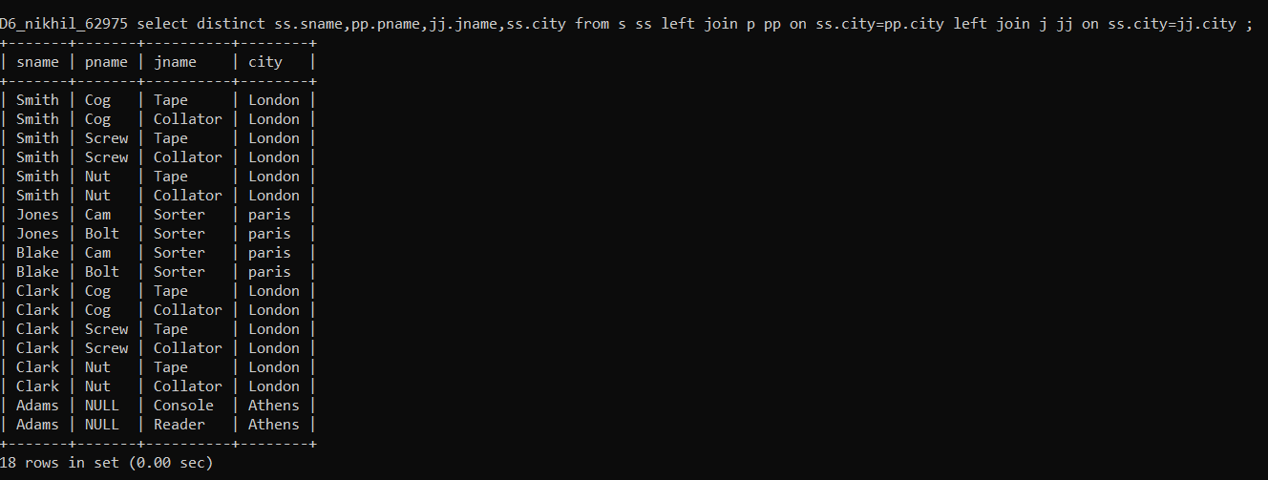

1. Display the Part name that is ‘Red’ is color, and the Quantity sold.

**select pp.pname,pp.color,spp.qty from p pp inner join sp spp on pp.`p#`=spp.`p#` where pp.color='red';**

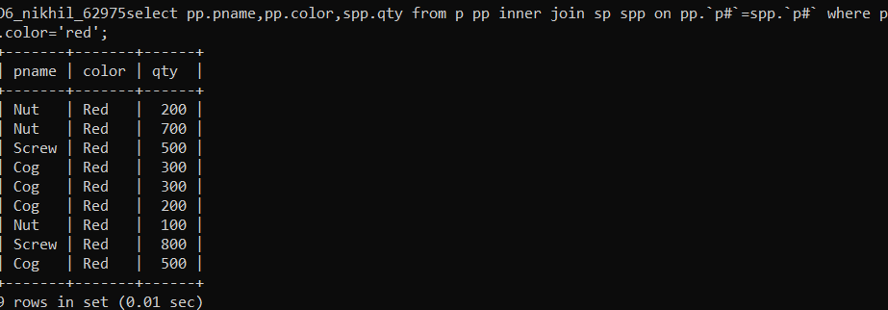

1. Display all the Quantity sold by Suppliers with the Status = 20.

**select ss.sname,spp.qty from s ss inner join sp spp on ss.`s#`=spp.`s#` where status=20;**

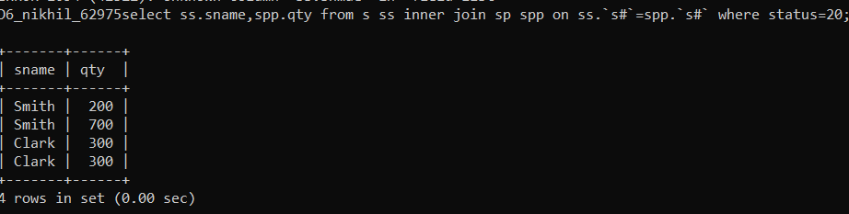

1. Display all the Parts and Quantity with a Weight > 14.

**select pp.pname,spp.qty from p pp inner join sp spp on pp.`p#`=spp.`p#` where weight>14;**

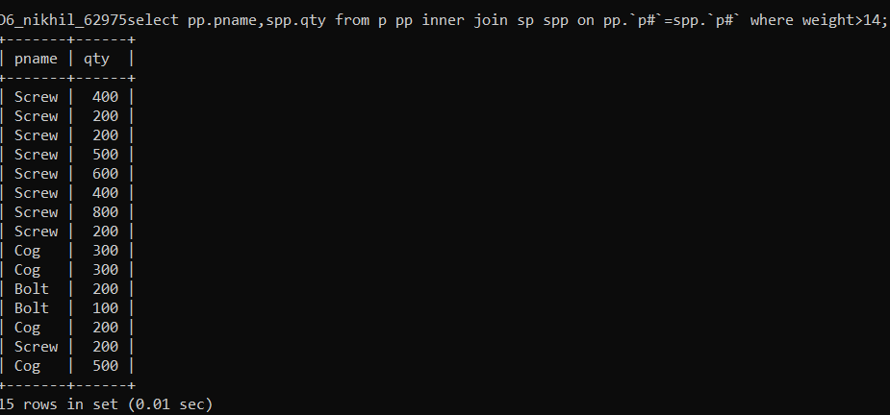

1. Display all the Project names and City, which has bought more than 500 Parts.

**select jj.jname,jj.city from j jj inner join sp spp on jj.`j#`=spp.`j#` where spp.qty>500;**

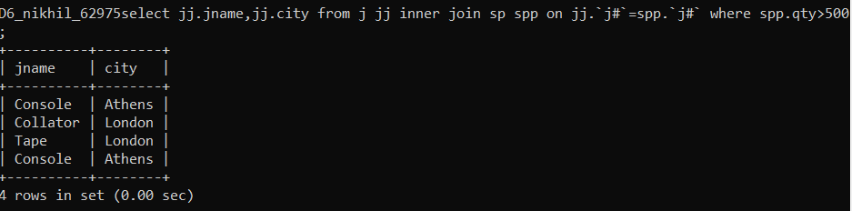

1. Display all the Part names and Quantity sold that have a Weight less than 15.

**select pp.pname,spp.qty from p pp left join sp spp on pp.`p#`=spp.`p#` where weight<15;**

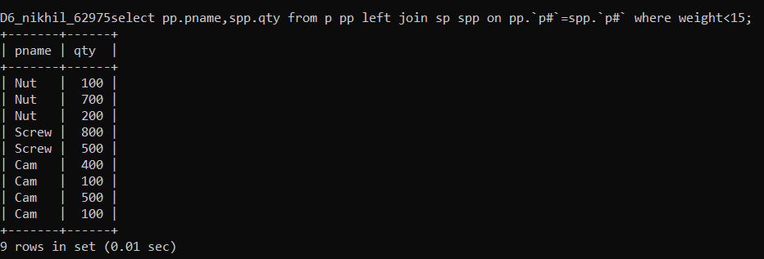

11. Display all the Suppliers with the same Status as the supplier, ‘CLARK’.

**select ss.sname,pp.pname,ss.status from s ss left join p pp on ss.city=pp.city where status=20;**

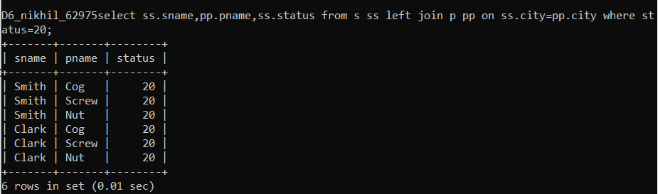

12. Display all the Employees in the same department as the employee ‘MILLER’.

**SELECT e.ename,e.deptno FROM emp e LEFT JOIN emp e1 ON e.empno=e1.empno WHERE e.deptno=20;**

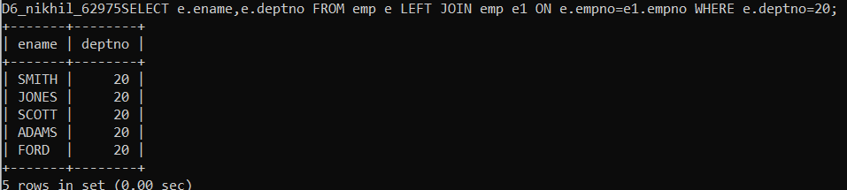

13. Display all the Parts which have more Weight than all the Red parts.

**select p1.pname,max(p1.weight) from p p1 inner join p p2 on p1.`p#`=p2.`p#` where p2.color='red' group by pname having max(p1.weight)>max(p2.weight);**



14. Display all the Projects going on in the same city as the project ‘TAPE’.

**select j1.jname,j1.city from j j1 inner join j j2 on j1.`j#`=j2.`j#` where j1.city='london' and j1.jname!='tape';**

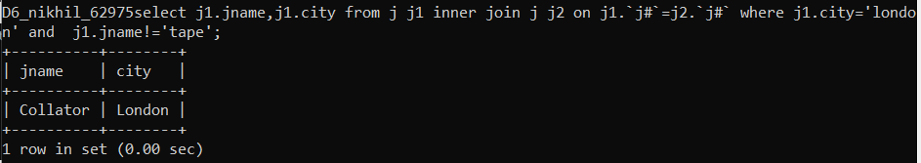

15. Display all the Parts with Weight less than all the Green parts.

**select p2.pname,p2.weight from p p1 cross join p p2 where p1.color='green' and p1.weight>p2.weight;**

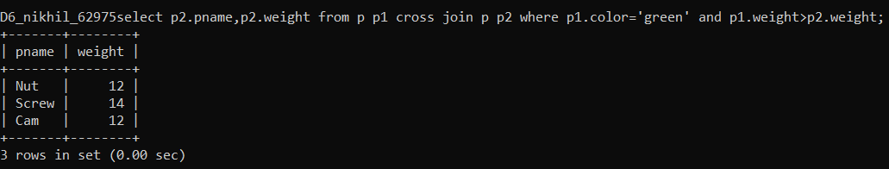

16. Display the name of the Supplier who has sold the maximum Quantity (in onesale).

**select ss.sname,max(spp.qty) as max_qty from s ss inner join sp spp on ss.`s#`=spp.`s#` group by ss.sname order by max_qty desc limit 1;**

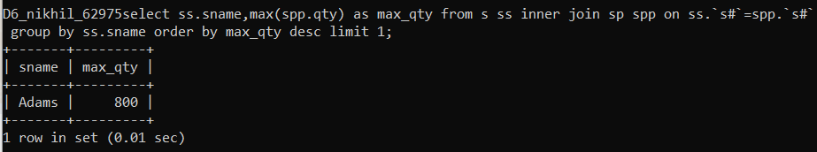

17. Display the name of the Employee with the minimum Salary.

**select ename,min(sal) as min_sal from emp group by ename order by min_sal limit 1;**

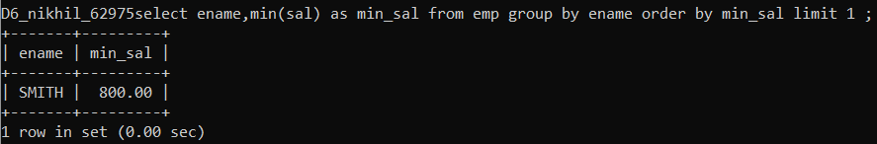

18. Display the name of the Supplier who has sold the maximum overall Quantity (sumof Sales)

**select ss.sname,sum(spp.qty) as total_qty from s ss inner join sp spp on ss.`s#`=spp.`s#` group by ss.sname order by total_qty desc limit 1;**

